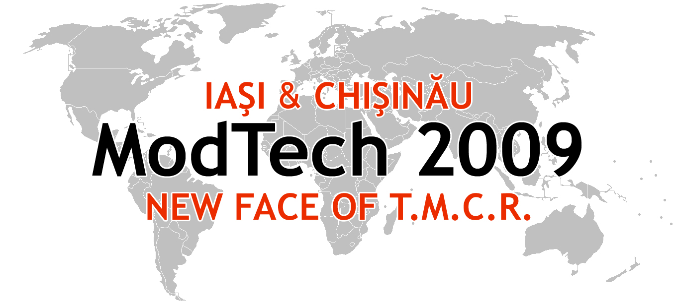

ModTech International Conference - New face of TMCR
Modern Technologies, Quality and Innovation - New face of TMCR
21-23rd May 2009
http://www.modtech.ro
SECTION 4
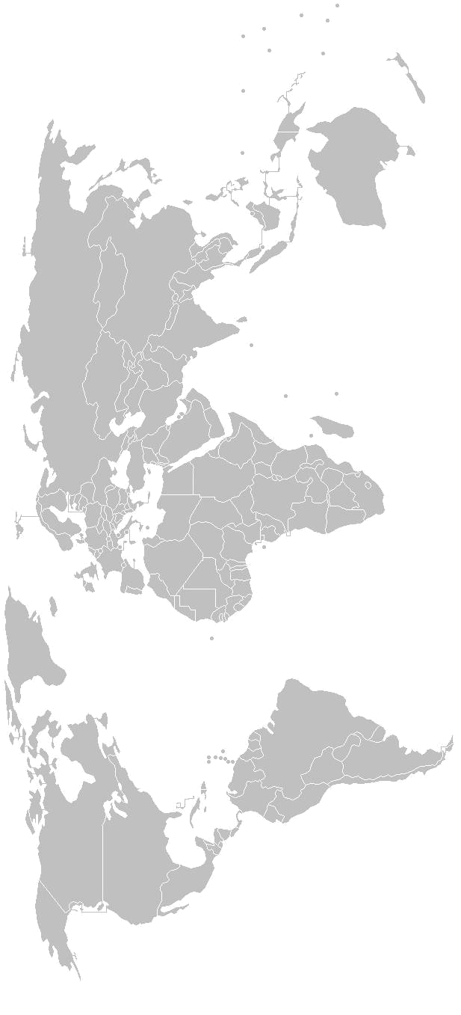
CAD/CAM/CAE/Cax

B-1-05, Laboratory of Computer Aided Design-2

Chair: Prof. Gavril Musca, Ph.D.
Co-Chair: Assoc. Prof. Constantin Carausu, Ph.D.
Secretary: Ovidiu Sava, Ph.D. Student

Thursday  May 21 | Papers & Authors
15²⁰-15³⁵ | Mapping applications in 3d studio max used for illustrating the technological dimensioning method  Ramona Clinciu
15³⁵-15⁵⁰ | Applications illustrating common intersections of solids in teaching technical drawing Ramona Clinciu
15⁵⁰-16⁰⁵ | Offline programming welding robots and simulation in robotstudio 5.10  Viorel Cohal, Cristian Gîdinceanu
16⁰⁵-16²⁰ | CAD import and offline simulation welding robots in robotstudio  Viorel Cohal, Cristian Gîdinceanu
16²⁰-16³⁵ | The CAD/FEM modelling for river-costal ship structures  Leonard Domnisoru, Dumitru Dragomir & Alexandru Ioan
16³⁵-16⁵⁰ | Using simulink/matlab software to simulate the operation of liberian fibres processing centre during the cold season  Liliana Indrie, Sabina Gherghel, Mariana Prichici & Ioan Almăşan
16⁵⁰-17⁰⁵ | Finite element analysis of the geometry of the tools used for the cup drawing process Monica Iordache
17⁰⁵-17²⁰ | Experimental investigations and finite element simulation of the marciniak punch test Monica Iordache
17²⁰-17³⁵ | The computer modeling for the rotary burs with the spectral edge distribution  Liu Huran , Wang Can, Liu Quanhong, Zou Changpin
17³⁵-17⁵⁰ | Numerical study in deep drawing with segmented blank-holder  Viorel Paunoiu & Dumitru Nicoara
17⁵⁰-18⁰⁵ | Matlab software to compute the resultant force and the resultant moment of a system of forces  Radu Ibănescu
18⁰⁵-18²⁰ | The moment of inertia calculation with autocad software  Adina Rusu
Friday  May 22 | Papers & Authors
9⁰⁰-9¹⁵ | CAE analyze of reaction from planetary precessional transmission  Anatolie Sochirean
9¹⁵-9³⁰ | The three-dimensional shaping of the brake pump with double circuit using informatical systems of design  Adrian Mihai Goanta
9³⁰-9⁴⁵ | Modern instruments of transfer of geometrical patterns in designing building machines and equipments  Adrian Mihai Goanta

